Buzzer

**What is Buzzer?**

**A buzzer is a simple electrocoaustic device designed to produce a buzzing or beeping sound when an electrical current is applied to it. It consists of a coil of wire wound around a magnetic core and a diaphragm or vibrating element, typically made of metal or plastic. When an electrical voltage is applied to the coil, it generates a magnetic field that interacts with the magnetic core. This interaction causes the diaphragm to vibrate rapidly, producing sound waves. Buzzer devices are commonly used in a wide range of applications, from alarm systems and timers to electronic games and appliances, to provide audible alerts or notifications. Their simplicity and reliability make them a popular choice for signaling purposes in various electronic and industrial settings.**

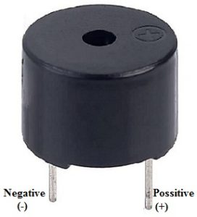

**Buzzer Symbol:**

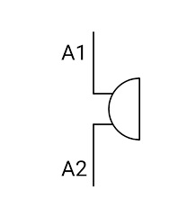

**Working of the Buzzer:**

The operation of a buzzer is based on the principle of electromagnetic vibration. Inside a typical buzzer, there is a coil of wire wrapped around a magnetic core, and a diaphragm or vibrating element, usually made of metal or plastic. When an electrical current is applied to the coil, it generates a magnetic field around the core. This magnetic field interacts with the core, causing it to become magnetized. The magnetic attraction and repulsion between the core and the coil rapidly move the diaphragm back and forth. As the diaphragm vibrates, it compresses and rarefies the air in front of it, creating pressure waves that propagate through the air as sound waves. This rapid vibration of the diaphragm produces the characteristic buzzing or beeping sound associated with buzzers. The frequency and volume of the sound can be controlled by varying the electrical current and the design of the buzzer, allowing for different tones and intensities to suit various applications.

The fundamental working principle of a buzzer involves the conversion of electrical energy into mechanical vibrations and then into audible sound waves. Inside the buzzer, the coil of wire is connected to an electrical circuit. When an alternating current (AC) or direct current (DC) voltage is applied to the coil, it induces a magnetic field around the magnetic core.

The diaphragm, which is positioned close to the magnetic core, is attracted and repelled by the magnetic field in rapid succession due to the alternating nature of the current. This magnetic attraction and repulsion force the diaphragm to move back and forth at the same frequency as the electrical signal, causing it to vibrate. These vibrations are transmitted to the surrounding air as pressure waves, creating sound waves that our ears perceive as audible sound.

The frequency or pitch of the sound produced by the buzzer is determined by the frequency of the electrical current applied to the coil. Higher frequencies result in higher-pitched sounds, while lower frequencies produce lower-pitched sounds. Additionally, the intensity or volume of the sound can be adjusted by controlling the amplitude of the electrical current or by modifying the physical design of the buzzer, such as the size and shape of the diaphragm.

A buzzer's operation is based on the interaction between an electromagnetic field created by the coil and the magnetic core, which drives the diaphragm to vibrate rapidly and produce audible sound waves. This simple yet effective mechanism makes buzzers an essential component in a wide range of applications where audible alerts or notifications are required.

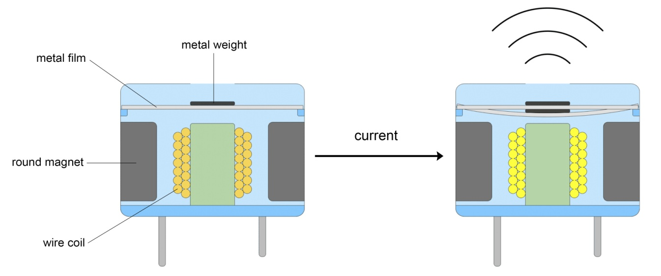

**Specifications:**

The specifications of the buzzer include the following**.**

* Color is black
* The frequency range is 3,300Hz
* Operating Temperature ranges from – 20° C to +60°C
* Operating voltage ranges from 3V to 24V DC
* The sound pressure level is 85dBA or 10cm
* The supply current is below 15mA

**Types of Buzzer:**

* Piezoelectric
* Electromagnetic
* Mechanical
* Electromechanical
* Magnetic

**Advantages**

* The**advantages of a buzzer** include the following.
* Simply Compatible
* Frequency Response is Good
* Size is small
* Energy Consumption is less
* The Range of Voltage usage is Large
* Sound Pressure is high

**Applications:**

The applications of the buzzer include the following.

* Communication Devices
* Electronics used in Automobiles
* Alarm Circuits
* Portable Devices
* Security Systems
* Timers
* Household Appliances
* Electronic Metronomes
* Sporting Events
* Annunciator Panels
* Game Shows

**Buzzer interfacing with Raspberry Pi:**

Interfacing a buzzer with a Raspberry Pi offers an avenue for integrating audible alerts and sound feedback into diverse projects. Buzzer modules, including passive and active buzzers, can be connected to the Raspberry Pi's GPIO pins, making it a straightforward process. Utilizing Python programming, you can control the buzzer's tone, frequency, and duration, enabling it to produce a variety of sounds, from simple beeps to more complex melodies. This capability is valuable for applications like designing a home automation system with audible notifications, creating interactive games with sound effects, or even building educational tools that use sound cues. By leveraging the Raspberry Pi's computational power and versatile connectivity options, interfacing a buzzer enhances the sensory dimension of your projects, making them more engaging and informative. Buzzer interfacing with the Raspberry Pi is a valuable skill for developers, educators, and hobbyists seeking to add audio feedback to their projects, enriching the user experience and expanding the scope of their creative endeavors

The integration of a buzzer with a Raspberry Pi introduces an exciting dimension to your projects by incorporating audible alerts and sound output. Buzzer modules, whether active or passive, can be easily connected to the Raspberry Pi's GPIO pins, making it a seamless process. Through Python programming, you have fine-grained control over the buzzer's auditory characteristics, allowing you to generate a wide range of sound patterns, from simple beeps to intricate melodies. This feature is invaluable for applications such as designing a home automation system with audible alarms or reminders, crafting educational tools with sound-based interactions, or building interactive art installations that engage the audience with audio feedback. The Raspberry Pi, with its computational prowess and extensive community support, serves as a robust platform for interfacing a buzzer, unlocking the potential for imaginative projects that combine both visual and auditory elements. Interfacing a buzzer with the Raspberry Pi offers developers, educators, and creative enthusiasts a dynamic tool for enhancing the user experience and broadening the horizons of their projects, from enhancing functionality to creating immersive multimedia experiences.

